**Creating Micro Services for account and loan:  
File Structure:**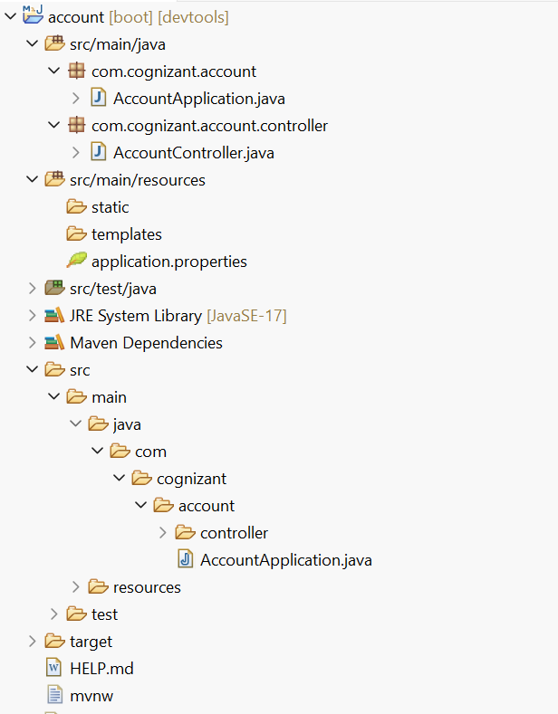  
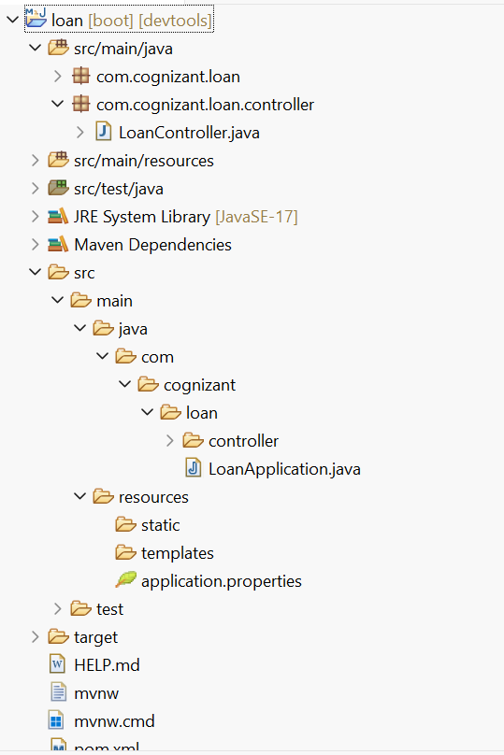

**Code:  
AccountController.java:  
package** com.cognizant.account.controller;

**import** org.springframework.web.bind.annotation.*;

**import** java.util.Map;

@RestController

@RequestMapping("/accounts")

**public** **class** AccountController {

@GetMapping("/{number}")

**public** Map<String, Object> getAccount(@PathVariable String number) {

**return** Map.*of*(

"number", number,

"type", "savings",

"balance", 234343

);

}

}

LoanController.java:  
**package** com.cognizant.loan.controller;

**import** org.springframework.web.bind.annotation.*;

**import** java.util.Map;

@RestController

@RequestMapping("/loans")

**public** **class** LoanController {

@GetMapping("/{number}")

**public** Map<String, Object> getLoan(@PathVariable String number) {

**return** Map.*of*(

"number", number,

"type", "car",

"loan", 400000,

"emi", 3258,

"tenure", 18

);

}

}

**Output:**